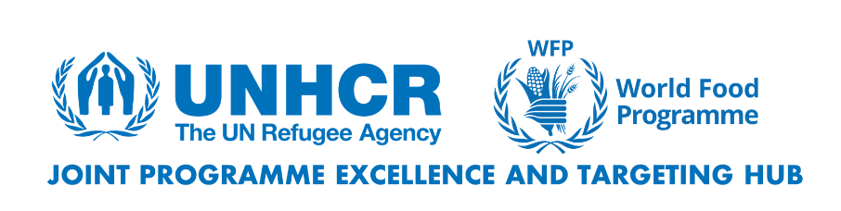

**UNHCR-WFP JOINT ANALYTICAL FRAMEWORK (JAF) SELF-RELIANCE MODULE**

**WHAT IS THE SELF-RELIANCE MODULE?**

The Self-Reliance module is an extension of the Joint Analytical Framework (JAF), designed to assist UNHCR and WFP in identifying livelihoods needs and opportunities to design joint self-reliance pathways. Its purpose is to offer a set of self-reliance indicators that assist country operations in formulating focused programs and initiatives within a shared analytical framework by providing essential data and insights. The module draws from existing UNHCR and WFP tools, surveys, and guidance to select the most relevant indicators for the purposes of joint programming. The indicators in the add-on module are not meant to be exhaustive; they offer a range of thematic indicators that can be adapted according to the context.

**WHEN SHOULD THE SELF-RELIANCE MODULE BE USED?**

The module should be used by UNHCR and WFP in any context where they are collaborating – or wish to collaborate – and are interested in understanding the ability of refugees and other forcibly displaced people to generate sustainable incomes through tailored livelihoods activities. The self-reliance module should be used alongside existing data to fill crucial information gaps and enhance livelihoods-related programme design. Additionally, UNHCR and WFP may independently employ the JAF to inform livelihoods and self-reliance programming, in contexts where only one of the agencies is operational. For example, as per the UNHCR programme manual, in contexts where WFP is not operationally present, UNHCR operations can use the JAF to inform their situational analysis and response planning.

**THREE LEVELS OF ANALYSIS**

In alignment with the JAF, the self-reliance module emphasizes key characteristics at national, community, and household levels. The indicators in this supplementary module are designed to complement those found in the JAF core module. The JAF basic needs and the self-reliance module can be employed in tandem to obtain a comprehensive understanding of the context and livelihood opportunities within a specific country operation.

**At the national level**, self-reliance indicators help analyze the host country's economic situation and policy frameworks governing services, work, finance, land, and freedom of movement. This information provides insights into the displacement context, opportunities, and barriers to self-reliance. It also tracks government and development initiatives to identify potential collaboration areas. National-level data is typically collected through Key Informant Interviews.

**At the community level**, the focus is on the specific characteristics of areas where displaced people are located, including economic opportunities, service availability, key actors, and support services. The aim is to identify available support, gaps, and program initiatives for future collaboration. Data is gathered through Focus Group discussions and Key Informant Interviews with refugees, other forcibly displaced people, and host communities.

**At the household level**, we analyze factors influencing the ability to meet basic needs and become self-reliant, such as income sources, asset ownership, access to services, protection risks, and long-term economic plans. Data is primarily collected through household assessments of refugees, other forcibly people and host community members (when required).

**KEY INDICATORS IN THE SELF-RELIANCE MODULE**

|  |  |  |
| --- | --- | --- |
| **National level** | **Community level** | **Household level** |
| **1. Legal Framework**  1.1 Access to land, water and services for agriculture purposes  1.2 Access to work  1.3 Freedom of movement  1.4 Right to self-organization and association  1.5 Access to financial services  1.6 Access to information and communication  1.7 Policies in place for socio-economic inclusion of refugees  **2. Availability of partners**  2.1 Presence of development/governmental/private sector actors working (or willing to work) with refugees | **3. Availability of services**  3.1 Financial service providers (formal and informal)  3.2 Technical skills and entrepreneurship support  3.3 NGOs/associations/humanitarian actors  3.4 Access to information about humanitarian development/assistance  3.5 Private investors  3.6 Local authorities and institutions  3.7 Employment support services  3.8 Markets and their functions  3.9 Social protection schemes and programmes  **4. Economic characteristics**  4.1 Main seasonal cycles and fluctuations on livelihoods opportunities among displaced/host populations  **5.External influencing factors**  5.1 Climate shocks and weather conditions affecting livelihoods of displaced people  5.2 Main opportunities/constraints to enhance access to specific livelihoods assets among host/displaced populations  5.3 Agricultural inputs accessibility  5.4 Livestock production/use  5.5 Main external shocks, negative trends and sources of hardship affecting access to food and livelihoods | **6. Food production**  6.1 Crop production  **7. Asset ownership and productivity** 7.1 Access to land for productive purposes  7.2 Households use of assets in practice  7.3 Agricultural inputs  7.4 Livestock production/use  **8. Access to services**  8.1 Access to an active bank account with a financial service provider  8.2 Access to affordable credit  8.3 Mobile payments  8.4 Savings  8.5 Remittances  8.6 Access to employment  8.7 Access to markets  8.8 Access to training/business capacity building/financial literacy  8.9 Access to social protection  **9. Economic plans**  9.1 Households’ economic long-term plans  **10. Challenges and fears**  10.1 Safety and risks |